Classification of Specific Organisms
Name
Institution
Date

Classification of Specific Organisms
Classification is the arrangement of living organisms, that is, plants and animals, in the taxonomic group according to their similarities and differences. The taxonomists are expected to classify the living organisms in following the taxonomic units of classification. This includes at least the organisms' kingdom, phylum or division in pants, class, order, family, genus, and species. The significance of classifying living organisms is tracing the evolutionary relationship between them and improving human knowledge of these plants and animals (Rudyshyn, 2017). The taxonomists end up identifying the names for living organisms, and this must obey the binomial nomenclature. This paper will trace the classification of Harvestmen (daddy-long-legs), Centipedes, and Moss. The habitat of the organism and the date and time of the day the collection of these organisms were done will be listed.
Harvestmen (Daddy-long-legs)
The classification of harvestmen is as follows
Kingdom: Animalia
Phylum: Arthropoda
Class: Arachnida
Order: Opiliones
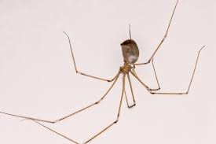
Fig. 1.0: image of opiliones species of harvestmen
There are over six thousand species of daddy-long-legs. The image provided above is of the most common daddy-long-legs. This organism was found walking on the wall surface. The typical habitat for this species is on moist habitats, especially under logs. I thought this organism was from a piece of wood I stepped on while I was collecting organisms.
The photo was taken on 5/19/2020 in the late evening at around 6:34 PM. Most of the characteristics we discussed were visible. For example, they have a fused body that looks more like a single oval structure than two segments. Some people confuse the harvestmen with the silk-producing spiders. These organisms do not produce any silk, but times they are found trapped in spider webs. It is essential for people not to kill the harvestmen even though they are a nuisance, and this is because this organism helps in praying small insects like mosquitoes that can be harmful to humans (Townsend, Pérez-González, & Proud, 2019).

Centipedes
Kingdom: Animalia
Phylum: Arthropoda
Subphylum: Myriapoda
Class: Chilopoda
Order: Lithobiomorpha
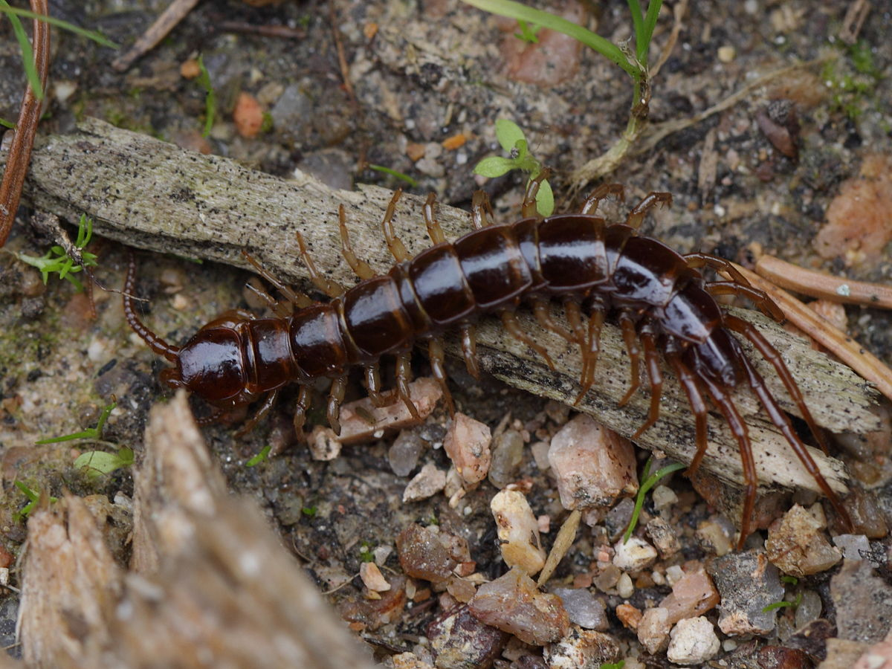
Fig 1.1: image of centipede (stone-centipede)
I found this centipede walking on stony surfaces. The common habitat for this centipedes is in moist temperate environments. However, the one I found was from the moist area around some rocks. The organism was identified on 5/19/2020 at around 5:48 PM. I saw almost all the characteristics of the centipedes in the species I identified. This includes segmented boy and a pair of walking legs on each segment, the presence of poisonous claws that are essential in injecting poison in the prey, and defense. The body shape of the centipede is dorsal-ventrally flattened. I did not identify the ocelli as we mentioned, and this was because the centipede was moving fast.
The other essential information is on the lifecycle of the centipedes. After mating, the females dig herself a nets under a rock and lays eggs in her safety nest. She coils the body around the eggs and ensures that the eggs are clean. In a short time, the eggs hatch and the young ones are left to feed themselves. When some centipedes bite people, it is a defense mechanism, and this organism does not harm humans unless oppressed. There are several orders of the centipedes; the information provided in this paper is concerning the specific class identified in the collection of species.

Moss
Kingdom: Plantae
Division: Bryophyta
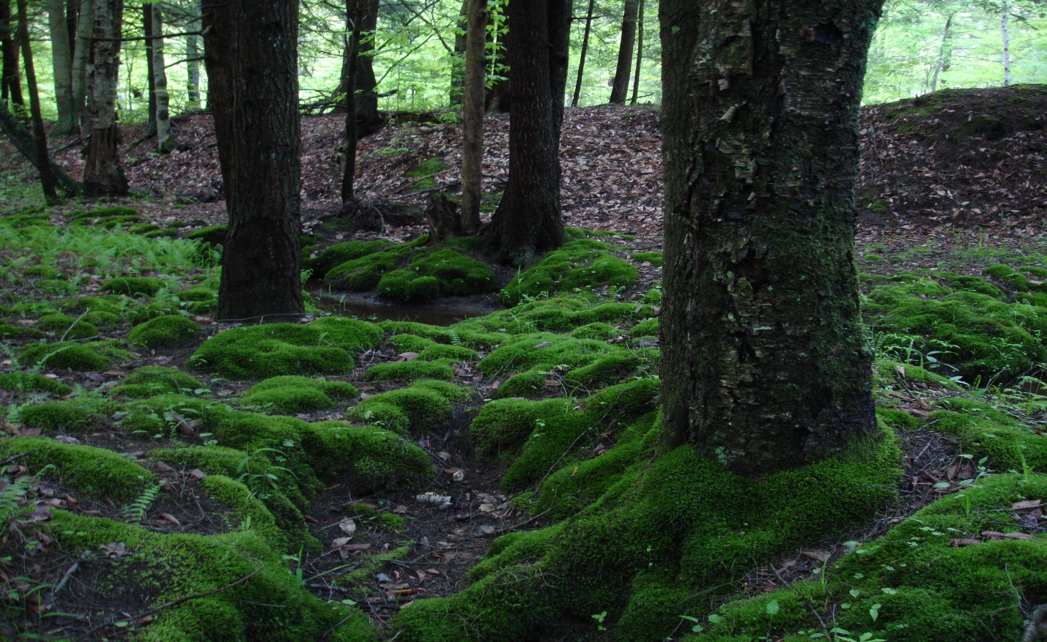
Fig 1.2: image of moss on the ground and back of trees
The moss's habitat is on ever- moist areas, around the tall trees, and moist rocky surfaces. As for my image, the moss was identified on the base of trees and the ground. The collection was done on 5/20/2020 in the morning at around 8:22 AM. After I looked closely at the moss, I determined that they lack a specified vascular system as in other green plants. In the moss, rhizoids were identified, and they are primarily for anchorage and in water retention. Both the gametophyte and the sporophyte generation were present in the identified mosses. However, the gametophyte phase was the most dominant. The presence of these two cycles in life is called the alteration of generation. The sporophyte is attached to the gametophyte and is thought to be parasitic upon it (Budke et al., 2018). People may confuse mosses with algae, but moss can grow taller and have distinct parts like stems and leaves.

References
Budke, J. M., Bernard, E. C., Gray, D. J., Huttunen, S., Piechulla, B., & Trigiano, R. N. (2018). Introduction to the Special Issue on Bryophytes.
Rudyshyn, S. D. (2017). Biodiversity: classification of organisms as scientific problem (Doctoral dissertation, ВНТУ).
Townsend Jr, V. R., Pérez-González, A., & Proud, D. N. (2019). Putative mating plugs of harvestmen (Opiliones, Laniatores). Zoologischer Anzeiger, 278, 101-109.

